# How to create Jmeter test Plan

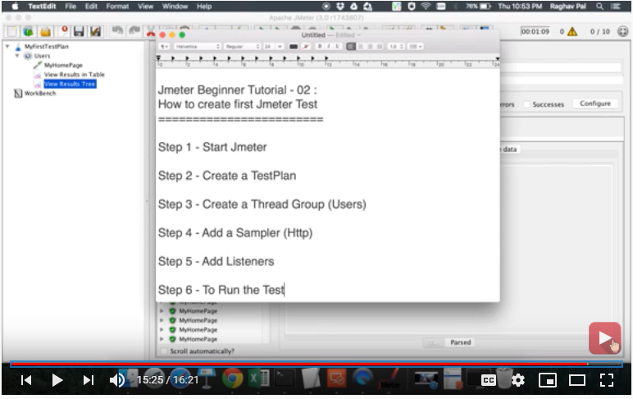

# Assertions

Assertion are used to test the response we got from request, in other words we can compare the response with our expected response.

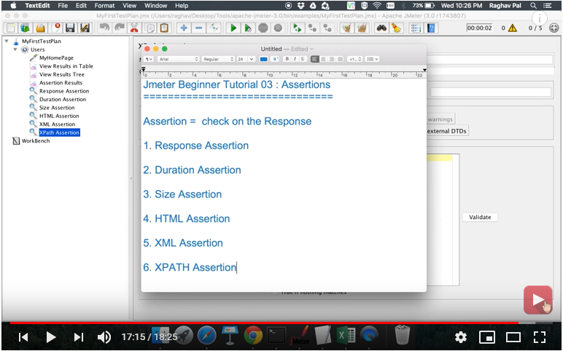

# Listeners.

Listeners are used to view the results of test plan, most commonly used listeners are

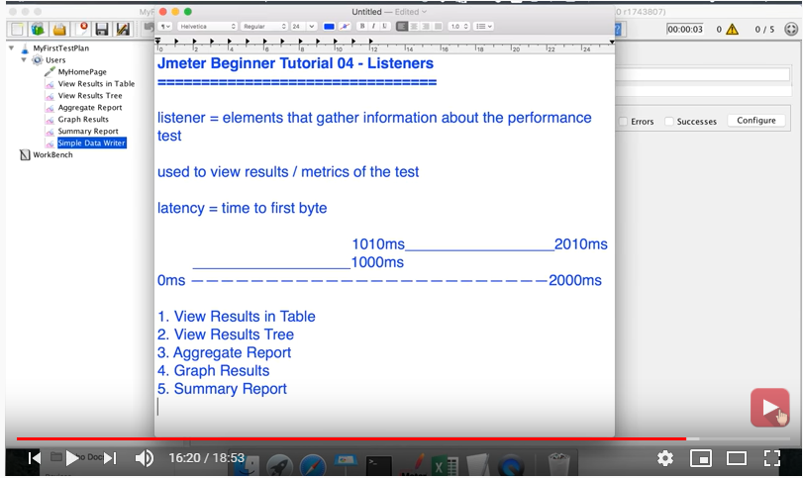

# UI Record Test

UI – RECORD TEST

USE : Whenever you want to test some steps of UI. Like Login🡪add cart🡪enter detail🡪proceed.

1. Download the Blaze meter chrome extension for UI recording.
2. Start recording.. save it as .JMX file
3. Open .jmx file in jmeter
4. Add listeners
5. Run

# Database Test

# Non-GUI Mode

Reasons to use :

Suits for Bulk test.

Easily integrate to Jenkins.

Consume more memory and resource.

## Configuration

1. Copy all data from reportgenrator.properties to user.proprties.
2. And append to user.properties

#------------------------------------------------------  
#SAVE SERVICE Configurations  
#---------------------------------------------------------  
jmeter.save.saveservice.bytes = true  
jmeter.save.saveservice.label = true  
jmeter.save.saveservice.latency = true  
jmeter.save.saveservice.response_code = true  
jmeter.save.saveservice.response_message = true  
jmeter.save.saveservice.successful = true  
jmeter.save.saveservice.thread_counts = true  
jmeter.save.saveservice.thread_name = true  
jmeter.save.saveservice.time = true  
jmeter.save.saveservice.print_field_names=true  
# the timestamp format must include the time and should include the date.  
# For example the default, which is milliseconds since the epoch:  
#jmeter.save.saveservice.timestamp_format = ms  
# Or the following would also be suitable

jmeter.save.saveservice.timestamp_format = dd/MM/yyyy HH:mm  
#save service assertion  
jmeter.save.saveservice.assertion_results_failure_message = true

## Test a plan

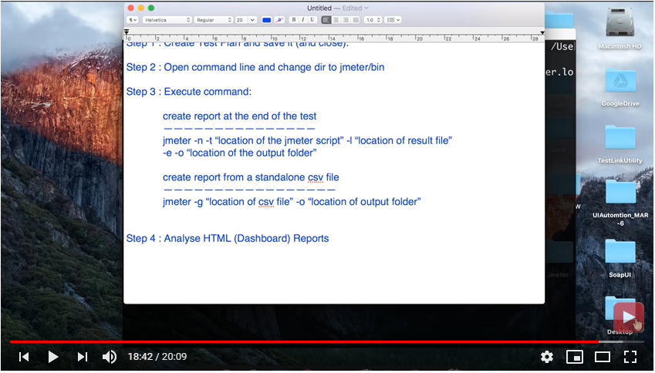

## Test and Generate .CSV output

jmeter -n -t **Practice/log_gen.jmx** -l **reports/log_gen.csv**

## Test and generate log files

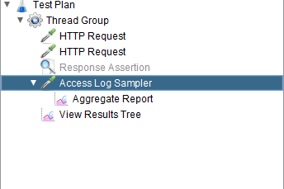

## Test and generate HTML reports

jmeter -n -t Practice/log_gen.jmx -l reports/log_gen.csv -f -e -o **reports/report1**

however u can generate log,csv,html at a time

* Add log generate steps in test plan
* Run above command
* Reports/report1 should be empty or add -f to command to forcefully delete files.
* U can genearate Html reports from log files.

# Import .Yaml file to .JMX

* import .yaml file contents to Postman collection.
* Export POSTMAN collection.
* Visit <https://loadium.com/postman-to-jmeter-converter/>

To convert postman collection to .jmx file.

* Open in Jmeter.

Note: Before exporting you must delete body data from every request.

# Bulk Data Test

